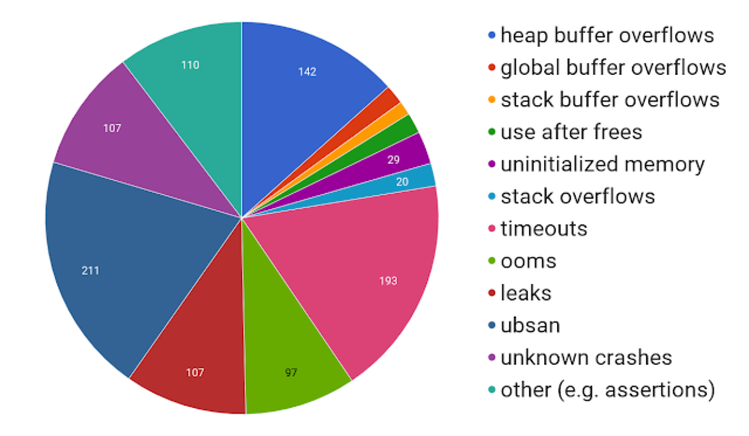

**https://github.com/google/oss-fuzz**